EM FX:

1. pricing is just the curve (forward market point). Adjusted by volatility (assuming 0.2 sharpe)

2. current account surplus (CLP,COP...)

3. taylor rule based: growth pressure, inflation pressure --> pressure on central bank intervention

4. hedging flows: long-term bond (UST 10 year), and equities

5. capital flows (high frequency portfolio flows). Rationale: it takes time to balance, but will reach limit at some point

6. trade surplus: supply and demand, commodity prices, oil prices

7. valuation: part of the supply and demand, but very slow moving

8. Balassa-samuelson effect: in the long term, fast growing countries should appreciate more, also very slow moving.

9. central bank may have to fight against appreciation through

10. mean reversion strategy

11. short GBP, it has too little carry, and needs to fight against large current account deficit.

12. some people just don't have to hedge their income, they want to keep their income as foreign currency.

13. all translated into the pct of gdp term

14. TIC flow? Second order derivative: it you want to know where the dollar is at, just look at the tic flow!

16 FT said we should have a very core inflation measure.

International trade and dollar borrowing?

Database management

Equity strategy:

equity is just compete with cash and bond yield.

z score of changes in bond

z score of changes in equity

European banks just hold a lot of bond

Script:

the model starts with the economic conditions. This by itself should tell the central bank if it should be easing or tightening policies. Forget about anything else. They don't care about what's priced in the world. They just want to know the economic variables that makes sense that they should be easing or cutting rates.

What are the things that matter? First start with the economic levels of activity. This tells the central banker how tight the economy is. In general, how tight the capacity is. That's an concept that you can't observe directly. It's an abstraction. There are certain amount of output in the economy that the inflation should not be rising or falling. In general the central banker run policy that to make sure you sit that neutral level for a while. When the growth is above potential that means the capacity is tightening. You're eating through slack. The central bank, their immediate goal is to make sure that the capacity is neutral. So your level of output is equal to a reasonable trend level of output. you have a potential growth rate of the economy, let's say it's 2%. You have an actual rate you observe. When growth rate is above potential, the trend growth will rise. The good thing for the central banker is this thing is here. That's the perfect situation for them. Think you're going to a rock concert. There's certain capacity in the stadium. Say you can take 100k people. If you have 50k, the price probably have to drop. This is at 120k, you have to push up the price. The capacity of the stadium change over time, there's a grow. Imagine the size of that stadium can grow every year. The number of people attending growing is like this. We estimate the trend line of the growth. We just take real GDP, and we eyeball to make sure it's reasonable. The potential growth is not really in dispute. It's not gonna really help that much. This is what every one kind of understand. The problem is that the capacity can not be directly observed. It's an abstraction. What we do is just to take a bunch of observable variables that represent this thing. And we take, essentially average them. If wage is growing faster it gives you a sense of capacity is tightening.

The next thing to think about is changes in economic condition. Technically growth minus potential should not be in levels. It represents what the change in slack is. We just bucket it here anyway to keep it simple. The next variable to look at is are they accelerating or decelerating. We created a impulsive measure of this. Citi has produced very good index that we use. The citi change index. If you take change in that, it gives you pretty good sense of what the change in growth is.

Then we've got a forward growth impulse. We started with 3, but actually 6m makes more sense, because we're talking about rates pricing over the next 2 years. 3 months create a lot of chop. The way we forward growth is just take: what are the components of GDP, we just create our forward growth pressure on these things. It's missing the fiscal impulse. Because it's something that can be done easily but take more time to do. Goldman has some estimate of it. All you want to figure out is whether government spending is going to be higher or lower in the next period. Cyclical adjusted. That's a dirty exercise. And the next key variable is gonna be export. Let's say, you have 2 exactly the same economies with same conditions, except that 1 has faster borrowing. It's not certain true that credit will lead spending. Even if you have more borrowing in 1 economy, you're going to want to tighten more than in the other 1. Because you cut the rate to raise the credit growth, if you have the credit growth, that is to say you don't have to run a easy policy.

Then I include forward inflation impulse. What are the free money thing that we know, that will drive the growth to some degree. It'll be oil in local fx terms, and how much the currency moves. We just stop over there with 2nd derivative in growth. The key is you observe these data everyday. It's daily series. The other thing that the central bank cares about, especially the US, is the global conditions. What is the financial condition impulse, globally. This should be replaced by forward growth impulse for each country. We know where the growth is changing, we know where the growth is versus potential, in the other one.

One day rate, 2 years forward, substract the essentially the cash rate. Substract a small risk premium from that. Using mean of zero. 1w swap to get as close as possible to cash rate. The market is really perfect at pricing the curve at a year ahead, or say 6m ahead. The big picture is quite good. People are very bad at pricing 2 years forward, that thing moves around a lot. 1 year forward, they're ok. 6m forward, it's just a game of what Powell is thinking. That's what everyone is very tight on. That's why we want to use 2 years forward. Looked at historically, and plug in a number. What's the trail in vol, multiply by the contract by 0.2.

Market talk 20191222

Any concern for the market?

I mean it's gonna be interesting coz the growth is gonna be stablized in a lot of places. But you gonna get more globally push to do more fiscal stimulus. I actually don't think bond is going to be very attractive now. There's not really... The equity is getting more stable. The promise of fiscal policy is enough for people to buy more equities even it's not flowing through immediately. That you know that the government is going to do more fiscal stimulus that's fine for equity investor. So equity market is probably gonna be reasonably strong. If they're strong, that's gonna be more supportive for growth and more supportive for earnings. That's going to carry on for a little bit.

Market talk about Mexico 20191227

This is the 1 year swap. Just to give you an idea what the short term interest rate looks like. They're running the tightest policy in the world, very aggressively. They hiked the interest rate from 3% to 8.5%. They wanted to stablize the currency. That's what they want. This is all the response they have. And so their economy is very weak now. But the bond price more hikes up here. It's crazy. And this was more than obvious cases that the rate was gonna rally. Because they're running very high interest rate, their economy was weak, and

Capital flow estimation (search for Jim oneil + weekly analyst):

1. Valuation: high valuation area are incentivised to do M&A in low valuation area

2. Using effective M&A to estimate the FDI

3. bond flow: use bond yield spread to estimate

4. trade weighted dollar, relative import prices -> export and import

5. world financial conditions -> world growth perspective

6. oil prices

7. TIC flow (flow logic: can't sketch forever?) Foreign purchase of US equity

8. import: value, volume, oil prices

9. FX reserve build up: vulnerability

10. electronic price: DRAM price?

11. Asian terms of trade: oil and DRAM prices

12. MOF flows for Japan

13. Bond benchmark adjustment

14. portfolio managers of bond allocation

15. interest rate differential

16. portfolio flow estimate: a- valuation (dividend yield, pension fund inflow??, multiples). b- positioning: sentix, TIC, zew, AAII?, economic consensus

17. import/export category: capital goods (investment spending), industrial supplies, autos, consumer goods(consumer spending).; energy, non-energy (commodities prices);

Mudit 2019-12-20

Adding couple more broker reviews for month end – average seems to be 30-35 Bn US equities to sell depending how much weighting they assign to quarterly rebalance, still worth 1-1.5% in spot.

**From MS :**

The Morgan Stanley QDS Pension Rebalancing Model estimates that there will be $11bn of outflows from US Equities over December month-end, with ~half of that flow expected to go into non-US Equities and half into Fixed Income and other assets.  $11bn outflows from US Equities is the 37th percentile since 2005.  The outflows from US Equities and inflows to non-US Equities result in net $6bn outflows from Equities overall, which is in-line with the median for aggregate Equities since 2005.  Note that these estimates may be smaller than other models because QDS models monthly rebalances, not quarterly, as price action exhibits more mean reversion around month-ends compared to quarter-ends.  Additionally, while the expected flow is not tremendous in size, subsequent price action could be exacerbated by low liquidity near year-end.

**From GS :**

**As of the close on Thursday, December 19th, the desk’s theoretical, model-based assumption estimates a net $40 billion of equities to sell from calendar-based flow given the moves in equities and bonds over the quarter:**

•         For the fourth quarter of 2019, equities **outperformed**fixed-income by 9.49% (S&P total-return +8.17%, 10yr total-return -1.32%). As a result, we estimate quarterly rebalancing flow of **$30 billion of equities to sell\***

•         Also, for the month of December, the S&P 500 has **outperformed**U.S. T-notes by 2.99% (SPX total-return +2.16%, 10-yr total-return -0.83%). This results in monthly estimated rebalancing flow of **$10 billion of equities to sell\***

•         Lastly, we saw one “trigger” event in the month of December, occurring on 12Dec19**.**

o   Equities cumulatively outperformed fixed-income by a 6.17% spread up to that date, leading to a net **$9 billion of equities to sell**

**Note: our assumption is trigger rebalancing occurs at/around time of event.**

Rebecca highlighting internals still good. Worth noting that she expects 50 Bn USD of equity selling into year end, this seems on the high side but could be worth 1.5-2% in spot as per historical impacts. Below is SPX price chart for end 2017 where we couldn’t rally despite tax cuts passing and ended the year at 2 week lows because of roughly 25 Bn equities selling (was a buying opportunity).

**From:** rebecca.cheong@ubs.com [mailto:rebecca.cheong@ubs.com]   
**Sent:** 20 December 2019 00:25  
**To:** Mehta, Mudit  
**Subject:** [EXTERNAL] We are only half-way there – more upside in 2020Q1

We are only half-way there – more upside in 2020Q1

### Sales and Trading commentary, not a product of UBS Research. For Institutional Investors only ###

**Upcoming Teach-in Events:**

•         Wednesday, 15 January 2020 in **Singapore**

•         Thursday, 16 January 2020 in **Hong Kong** – We are at ~90% capacity, please contact your local sales for invitation if you are interested

•         Wednesday, 29 January 2020 in **Sao Paolo**

•         Wednesday, 5 March 2020 in**Sydney**

**Summary:**

**I will be on block leave for the next two weeks and back on January 6.  Last year, I saw the Northern Lights in Iceland.  This year, we are heading to Niseko in Hokkaido, Japan to enjoy some dry snow skiing.  Stay warm!  Merry Christmas & Happy New Year!!!!!**

•         I have been getting a lot of questions if the recent rally has changed my view – answer is no.  Q4 return so far has been in-line with my expectation of +5-10%.  So far, SPX is up 8% QTD

•         I remain bullish into 2020Q1 since upside dislocation just started in Sep 2019 in our model and it should last more than 3 months

•         Investor positioning has gone from extremely bearish to moderate with many positioning hovering around 40%-70%-tile ranks – no stretched position yet

•         Our CTA model shows that we are just at the beginning of a strong momentum period (not the end) and we are far away from meaningful sell triggers currently

•         Based on intraday recovery score comparison since 2011, current year-end trend is the strongest with 2M score @ 32%, a rise of +13% vs 1M ago.  Normally, a stable recovery score (sentiment) at prior year-end was good enough to support a beginning of year grind higher trends in 2012 (+12% in Q1), 2013 (+12% in Q1) and 2017 (+8% in Q1).  During those periods, beginning of year buying demand wasn't met by investors dumping stocks since recovery score (conviction) didn’t collapse

•         Lastly, I expect the typical Q4 hedge fund upside chasing to be delayed into Q1 as many funds have cut down their risks (both net and gross) early on to lock in their performance gain this year, post a challenging 2018 year

•         One major sell risk before year-end is pension year-end rebalancing of up to $50 bil of equity to sell – the largest month-end selling since Dec 2016.  Since our other market internal models remain healthy, use this opportunity to buy the dip to gain upside exposure into Q1 2020

**Overview:**

**I have been getting a lot of questions if the recent rally has changed my view – answer is no**.  Q4 return so far has been in-line with my expectation of +5-10% (vs 8% QTD) and below is why I remain bullish into 2020Q1.

•         **Figure 1:** Our model focuses on **major dislocation signs** especially when conviction and leverage deviates significantly as depicted in Figure 1.  Our model shows major downside risk where conviction dropped too fast vs a rising leverage in early Oct 2018, as well as major upside risk where **conviction rose sharply vs an extremely low leverage in early Sep 2019**.  We are just 3 months into this low volatility, grind higher rally and there should be **more room to go in 2020** given the significance and rarity of the dislocation

•         **Figure 7:** In Sep, our model output was obvious as conviction was very strong from intraday recovery score to excess flow while leverage was very low from UBS PB, CFTC, hedged positioning to retail flows.  In Oct and Nov, while conviction has remained strong and stable, **investors were fighting the rally which lengthened and extended the rally, and reinforced our high conviction in Q4 upside**

•         **Figures 11, 15-19:** Finally, over the last two weeks in Dec, we started to see **positioning get longer but nothing are over-stretched yet** with many positions hovering around 40-70%-tile versus 3Y history – CFTC lev fund exposure in SPX futures @ 14%-tile, VIX ETN + CFTC VIX futures @ 80%-tile (i.e. well-hedged), SPY P/C ratio @ 47%-tile, UBS PB Net exposure @ 51%-tile, Risk Control leverage @ 58%-tile and Risk Parity leverage @ 75%-tile.  Even for CTA exposure, although they are around 80%-100% long global equities, the **long-term strategies just turned long less than 3 months ago**.   This marked the **beginning of a strong momentum period (not the end) and we are far away from meaningful sell triggers currently**

•         **Figures 2 – 6:** In particular, as we compare the current intraday recovery score trend vs past year-ends, **the current condition is one of the strongest at a high level and a rising trend**.  As shown in figures 2 – 5, when recovery score collapsed into year-end, it tended to lead a sell-off immediately after new year (2014, 2015, 2016, 2018 – Figures 4 & 5).  However, **as long as recovery score (sentiment) remained stable at prior year-end**, the typical beginning of year buying demand from retail investors, retirement funds and hedge fund managers were enough to create a **continuously grind higher market in Q1 (2012, 2013, 2017 – Figures 2 & 3).**  So far in Dec, recovery score is not only strong, it has been rising, which suggests that there is a low likelihood of investors changing their trading behavior and conviction drastically and dumping stocks at the beginning of 2020

•         Lastly, one of the typical key drivers of Q4 seasonality is usually hedge fund upside chasing in a strong equity return year.  However, the loss in 2018, followed by a strong performance in 2019 have caused many funds to cut risk significantly (both net and gross) into year-end to lock in their performance gain.  I believe this has **inevitably delayed the normal Q4 upside chasing into Q1 with a bias in bargain hunting to set up for 2020**

•         One major sell risk before year-end is pension year-end rebalancing of up to $50 bil of equity to sell – the largest month-end selling since Dec 2016.  Since our other market internal models remain healthy, use this opportunity to buy the dip to gain upside exposure into Q1 2020

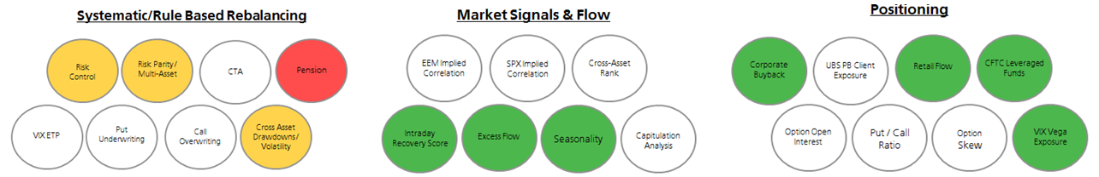

**Figure 1**

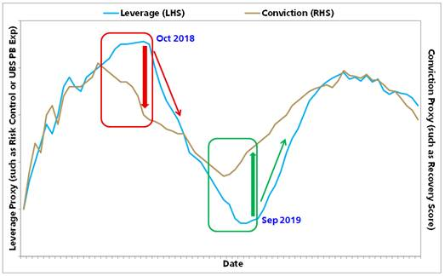

**Figures 2 - 5**

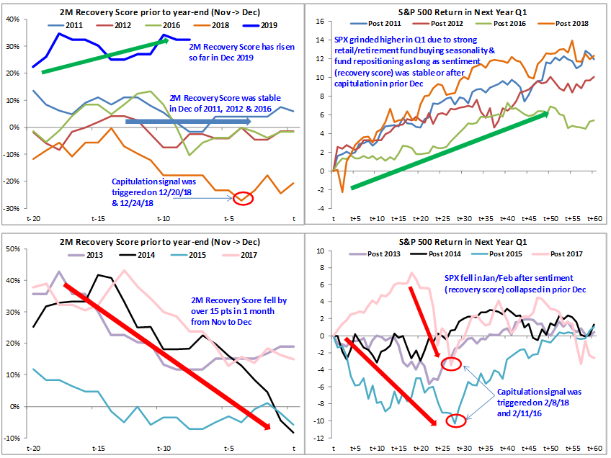

**Figure 6**

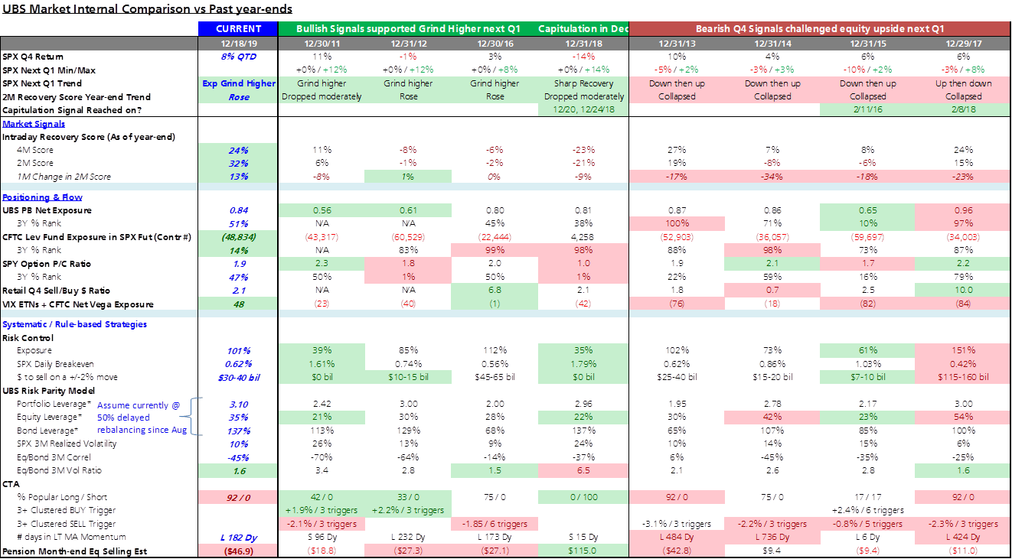

**Key Reports in late 2018 & 2019:**

Oct 10, 2018 – [A perfect storm is brewing](https://nam03.safelinks.protection.outlook.com/?url=https%3A%2F%2Fneo.ubs.com%2Fr%2F%3Fid%3Dhb6ac92%2C1a17062%2C1a1714a%26inst%3DV7%0D%0A%26did%3DAC7-S-27357282%26off_id%3DAC7-S-13687377395613%26ma%3DY4E494B414E4A4543%26camp_id%3DEM%3AUNKW%3A2019-12%3A19%3ASmartEmail&data=02%7C01%7Cmmehta%40caxton.com%7C627432386eca4bccdafc08d784e3a56b%7C70c99524736c49f4b73e75d7fa126cf9%7C0%7C0%7C637123985589725203&sdata=WHVXvYZwm2WcJEWOaTJ18XRH%2Fb4CjEWqzTRnC00BE%2BI%3D&reserved=0)

Dec 11, 2018 – [A coincidence or NOT? – 1998, 2000, 2008, 2018](https://nam03.safelinks.protection.outlook.com/?url=https%3A%2F%2Fneo.ubs.com%2Fr%2F%3Fid%3Dhb6ac92%2C1a17062%2C1a1714b%26inst%3DV7%0D%0A%26did%3DAC7-S-27357282%26off_id%3DAC7-S-13687377395614%26ma%3DY4E494B414E4A4543%26camp_id%3DEM%3AUNKW%3A2019-12%3A19%3ASmartEmail&data=02%7C01%7Cmmehta%40caxton.com%7C627432386eca4bccdafc08d784e3a56b%7C70c99524736c49f4b73e75d7fa126cf9%7C0%7C0%7C637123985589725203&sdata=dahD7PLxSA7pmMIm8lbDwH9nOhQQ%2FtrWR1wtNn%2F94tU%3D&reserved=0)

Jan 14 – [Excess](https://nam03.safelinks.protection.outlook.com/?url=https%3A%2F%2Fneo.ubs.com%2Fr%2F%3Fid%3Dhb6ac92%2C1a17062%2C1a1714c%26inst%3DV7%0D%0A%26did%3DAC7-S-27357282%26off_id%3DAC7-S-13687377395615%26ma%3DY4E494B414E4A4543%26camp_id%3DEM%3AUNKW%3A2019-12%3A19%3ASmartEmail&data=02%7C01%7Cmmehta%40caxton.com%7C627432386eca4bccdafc08d784e3a56b%7C70c99524736c49f4b73e75d7fa126cf9%7C0%7C0%7C637123985589735199&sdata=6FV1mIoyjnxoJE2dF3Ismhnozqz9UsdJPYGAkzzCUxY%3D&reserved=0)[flow supports our bearish view – 2600 resistance, 2200 downside](https://nam03.safelinks.protection.outlook.com/?url=https%3A%2F%2Fneo.ubs.com%2Fr%2F%3Fid%3Dhb6ac92%2C1a17062%2C1a1714d%26inst%3DV7%0D%0A%26did%3DAC7-S-27357282%26off_id%3DAC7-S-13687377395616%26ma%3DY4E494B414E4A4543%26camp_id%3DEM%3AUNKW%3A2019-12%3A19%3ASmartEmail&data=02%7C01%7Cmmehta%40caxton.com%7C627432386eca4bccdafc08d784e3a56b%7C70c99524736c49f4b73e75d7fa126cf9%7C0%7C0%7C637123985589735199&sdata=4r3SyEMRrNnBPdDxKYJxNEXEJTZy9%2BNWCl%2F%2FM6ZonDc%3D&reserved=0)

Feb 4 – [External Catalyst resets Market Internals](https://nam03.safelinks.protection.outlook.com/?url=https%3A%2F%2Fneo.ubs.com%2Fr%2F%3Fid%3Dhb6ac92%2C1a17062%2C1a1714e%26inst%3DV7%0D%0A%26did%3DAC7-S-27357282%26off_id%3DAC7-S-13687377395617%26ma%3DY4E494B414E4A4543%26camp_id%3DEM%3AUNKW%3A2019-12%3A19%3ASmartEmail&data=02%7C01%7Cmmehta%40caxton.com%7C627432386eca4bccdafc08d784e3a56b%7C70c99524736c49f4b73e75d7fa126cf9%7C0%7C0%7C637123985589745197&sdata=YaieN5ToDyiov6WNdWVwvFrKshiI%2FUUbPFh95efNRnY%3D&reserved=0)

May 21 – [Market conditions are set up well for another surprise equity rally](https://nam03.safelinks.protection.outlook.com/?url=https%3A%2F%2Fneo.ubs.com%2Fr%2F%3Fid%3Dhb6ac92%2C1a17062%2C1a1716d%26inst%3DV7%0D%0A%26did%3DAC7-S-27357282%26off_id%3DAC7-S-13687377395648%26ma%3DY4E494B414E4A4543%26camp_id%3DEM%3AUNKW%3A2019-12%3A19%3ASmartEmail&data=02%7C01%7Cmmehta%40caxton.com%7C627432386eca4bccdafc08d784e3a56b%7C70c99524736c49f4b73e75d7fa126cf9%7C0%7C0%7C637123985589745197&sdata=kWq13gfHP1hZnNbiSFChSUEatzD1JErNzGEBIoUAcXU%3D&reserved=0)

Aug 26 – [Current market internal is the strongest since May](https://nam03.safelinks.protection.outlook.com/?url=https%3A%2F%2Fneo.ubs.com%2Fr%2F%3Fid%3Dhb6ac92%2C1a17062%2C1a1716e%26inst%3DV7%0D%0A%26did%3DAC7-S-27357282%26off_id%3DAC7-S-13687377395649%26ma%3DY4E494B414E4A4543%26camp_id%3DEM%3AUNKW%3A2019-12%3A19%3ASmartEmail&data=02%7C01%7Cmmehta%40caxton.com%7C627432386eca4bccdafc08d784e3a56b%7C70c99524736c49f4b73e75d7fa126cf9%7C0%7C0%7C637123985589755194&sdata=lTaWz72HXO7%2Fmcn4OOhjdJVtUT%2FdnJpz68AWTj1vGtM%3D&reserved=0)

Sep 5 – [The most green bubbles in two years – Turning more bullish](https://nam03.safelinks.protection.outlook.com/?url=https%3A%2F%2Fneo.ubs.com%2Fr%2F%3Fid%3Dhb6ac92%2C1a17062%2C1a1716f%26inst%3DV7%0D%0A%26did%3DAC7-S-27357282%26off_id%3DAC7-S-13687377395650%26ma%3DY4E494B414E4A4543%26camp_id%3DEM%3AUNKW%3A2019-12%3A19%3ASmartEmail&data=02%7C01%7Cmmehta%40caxton.com%7C627432386eca4bccdafc08d784e3a56b%7C70c99524736c49f4b73e75d7fa126cf9%7C0%7C0%7C637123985589755194&sdata=9uqZlhUBpD4udU2d7P1NR9XdLw1kQ7%2Fn7%2Bgsb18k7yk%3D&reserved=0)

Sep 24 – [Upside Dislocation Drivers + Q4 Seasonality Support](https://nam03.safelinks.protection.outlook.com/?url=https%3A%2F%2Fneo.ubs.com%2Fr%2F%3Fid%3Dhb6ac92%2C1a17062%2C1a17170%26inst%3DV7%0D%0A%26did%3DAC7-S-27357282%26off_id%3DAC7-S-13687377395651%26ma%3DY4E494B414E4A4543%26camp_id%3DEM%3AUNKW%3A2019-12%3A19%3ASmartEmail&data=02%7C01%7Cmmehta%40caxton.com%7C627432386eca4bccdafc08d784e3a56b%7C70c99524736c49f4b73e75d7fa126cf9%7C0%7C0%7C637123985589755194&sdata=mO2sgj6nmfyL%2BXFqgcekCd4VLZ9kBtlzb55q%2FKkxJ%2Fc%3D&reserved=0)

Oct 28 – [Conviction in Q4 +5%-10% rally remains high](https://nam03.safelinks.protection.outlook.com/?url=https%3A%2F%2Fneo.ubs.com%2Fr%2F%3Fid%3Dhb6ac92%2C1a17062%2C1a17171%26inst%3DV7%0D%0A%26did%3DAC7-S-27357282%26off_id%3DAC7-S-13687377395652%26ma%3DY4E494B414E4A4543%26camp_id%3DEM%3AUNKW%3A2019-12%3A19%3ASmartEmail&data=02%7C01%7Cmmehta%40caxton.com%7C627432386eca4bccdafc08d784e3a56b%7C70c99524736c49f4b73e75d7fa126cf9%7C0%7C0%7C637123985589765182&sdata=3k22gyZ%2FxfFs5WmPkwzjrZmZ7HH3y7B66QVwYgHyHsA%3D&reserved=0)

Dec 5 – [Strong market signals + Well-hedged positions - grind higher into early 2020](https://nam03.safelinks.protection.outlook.com/?url=https%3A%2F%2Fneo.ubs.com%2Fr%2F%3Fid%3Dhb6ac92%2C1a17062%2C1a17172%26inst%3DV7%0D%0A%26did%3DAC7-S-27357282%26off_id%3DAC7-S-13687377395653%26ma%3DY4E494B414E4A4543%26camp_id%3DEM%3AUNKW%3A2019-12%3A19%3ASmartEmail&data=02%7C01%7Cmmehta%40caxton.com%7C627432386eca4bccdafc08d784e3a56b%7C70c99524736c49f4b73e75d7fa126cf9%7C0%7C0%7C637123985589765182&sdata=r%2Bj1ZRUqaszTpXLcSttajp9t4rZ5zG1pWLBfq11Qw6k%3D&reserved=0)

**Model Details:**

**Market Signals**

•         ***Intraday Recovery Score (Figure 7):*** 2M Recovery Score has risen to 32% while 4M Score remains at 24% => still bullish

•         ***Excess Flow:*** In a grind higher market, excess flow is expected to be low to nothing since investors only need to adjust their portfolios marginally.  During this time, we focus more on the relative volume across products instead of above average flow.  Since mid-Oct, cash volume has led the market 75% of the time where cash volume/average exceeded both SPY and SPX futures volume/average by at least 15%.  This suggests a healthy longer term investment environment instead of speculative short-term trading, and is supportive of a grind higher market

•         ***Seasonality (Figure 8):*** In "[9/24 Upside Dislocation Drivers + Q4 Seasonality Support](https://nam03.safelinks.protection.outlook.com/?url=https%3A%2F%2Fneo.ubs.com%2Fr%2F%3Fid%3Dhb6ac92%2C1a17062%2C1a17173%26inst%3DV7%0D%0A%26did%3DAC7-S-27357282%26off_id%3DAC7-S-13687377395654%26ma%3DY4E494B414E4A4543%26camp_id%3DEM%3AUNKW%3A2019-12%3A19%3ASmartEmail&data=02%7C01%7Cmmehta%40caxton.com%7C627432386eca4bccdafc08d784e3a56b%7C70c99524736c49f4b73e75d7fa126cf9%7C0%7C0%7C637123985589775180&sdata=clLO2H8U1ZItYgS5wv%2B8eMuGzTTLQklMoylXdtGV1XM%3D&reserved=0)," we highlighted the case for a strong Q4 seasonality this year.  So far, we are up 8% QTD.  Based on historical analysis of intraday recovery score vs seasonality buying from retail investors and fund managers in Q1, we expect the grind higher trend to continue into 2020.  In particular, the net buying impact from investors was strong in Q1 historically when their sentiment (as measured by recovery score) was stable at year-end.  Lastly, the hedge fund upside chasing phenomenon that we expected in Q4 only partially played out as some strong performing funds chose to wind down their book/risk before year-end to lock in gain instead of chasing upside.  For these funds, I expect them to deploy capital again in 2020 and simply delayed their buying demand from Q42019 to Q12020

**Systematic/Rule-based Rebalancing**

•         ***Risk Control Funds (Figure 9):*** Current SPX 10% RC fund leverage @ ~100% or 58%-tile vs 3Y history.  We continue to expect them to add ~10% (at least $30-40 bil) in the coming month with daily breakeven @ 62 bps.  Historically, 130%-150% was the leverage level that could trigger large systematic selling so we are still far away from it.  If we shock SPX -2% for one day in Feb 2018, Oct 2018 and the current, our model estimated $95-135 bil, $65-95 bil and $30-40 bil of equity selling respectively.  Therefore, although risk control rebalancing risk has risen, it remains under control and is not likely to last for more than two days.

•         ***Risk Parity Funds (Figure 10):*** UBS Risk Parity model expected significant asset allocation from bond to equity over the last few months.   However, the moderate weakness in treasury bonds suggested that rebalancing was likely very slow.  Hence, we assume that only 50% of the rebalancing was executed, and their current equity exposure is estimated ~75%-tile and bond exposure ~52%-tile vs 3Y history. With a close to 10Y low equity/bond 3M realized volatility ratio @ 1.7x, equities should continue to benefit from asset allocation by multi-asset & risk parity rebalancing

•         ***CTA Funds (Figure 11):*** CTA funds started to be long equities globally but since it is just the beginning, there is almost no sell triggers and buy triggers.  In fact, most strategies have been in the long-term strategy for less than 80 days, which imply an early stage of an upside momentum trend which could last for many more months before it turns

•         ***Put Underwriting & Call Overwriting Funds:*** S&P 500 is up ~3-4% vs expiration week in Nov.  We expect many put underwriters and call overwriters have already rolled up their options prior to expiry tomorrow, so short-term buying boost for them should be small

•         ***Pension Funds (Figures 12 & 13):*** Our model estimates pension month-end selling @ 50 bil with $33 bil from month-end rebalancing and $17 bil from monthly triggered rebalancers.  This is one of the biggest monthly sell rebalancing since Dec 2016, so we expect their selling could exert some pressure to the market during the upcoming holiday season when liquidity is low.   Since our other market internal models remain healthy, use this opportunity to buy the dip to gain upside exposure into Q1 2020

**Positioning & Flow**

•         ***UBS PB Exposures (Figures 14 & 15):*** UBS gross exposure has risen to 2.29x while net has fallen to 0.84x, at 29%-tile and 51%-tile vs 3Y history respectively.

•         ***UBS RMM Flow:*** Since end of Jan 2019, UBS RMM Sell/Buy Ratio has been at ~3x, that continued over the last two months.  This suggests that retail investors have accumulated cash over time that would allow them to buy during sell-off days like what they have been doing since August

•         ***CFTC Lev Funds (Figure 16):*** CFTC leveraged fund exposure in S&P 500 futures have covered some shorts but remain at low exposure with %-tile ranks at 20%-tile vs 1Y and 14%-tile vs 3Y histories.  This implies macro investors are slowly covering their excessive short positions

•         ***VIX Net Vega Exposure (Figure 17****):* VIX Net Vega Exposure across ETFs and CFTC leveraged fund exposures are at $48 mil vega, or 80%-tile vs 3Y history.   This continues to suggest that investors are relatively well-hedged via volatility products

•         ***Option P/C Ratio & Open Interest (Figures 18 & 19):*** SPY put open interest has risen slowly as we approach option expiry.   Current SPY Put Open Interest @ 100%-tile vs 1Y and 60%-tile vs 3Y histories, while SPY P/C ratio @ 47%-tile vs 3Y.  A month ago, investors were well-hedged and now they are right around average

•         ***Corporate Buyback (Figure 20):*** UBS Research estimates that corporate buyback will start slowing down but still high at @ a range of $25-30 per week over the next weeks

**Figures 7 & 8**

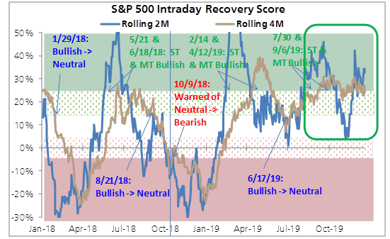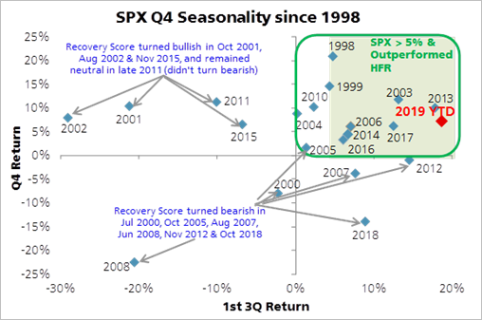

**Figures 9 & 10**

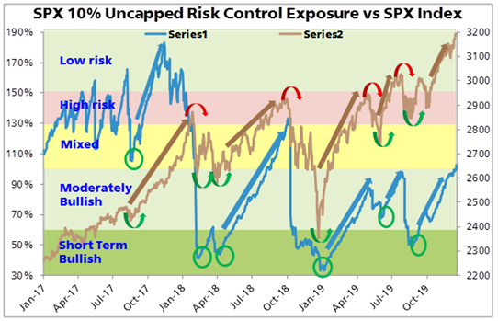 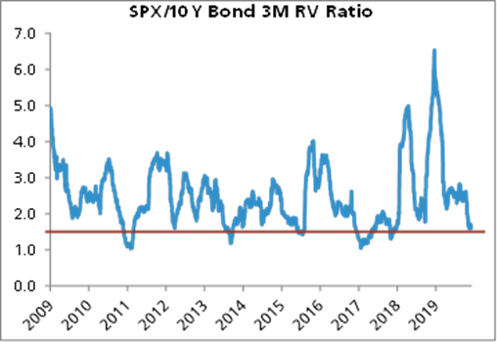

**Figure 11**

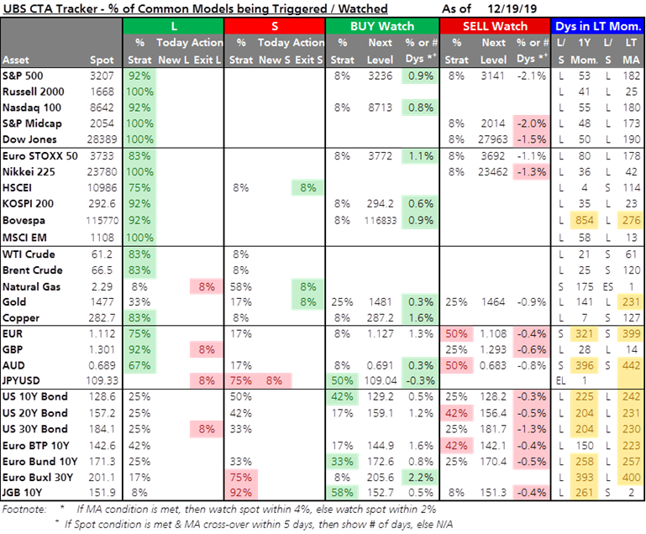

**Figures 12 & 13**

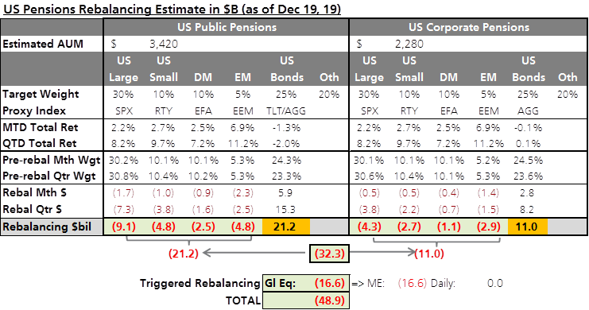

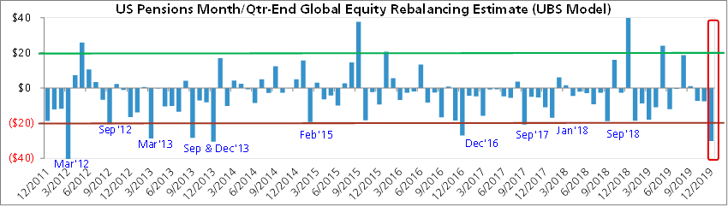

**Figures 14 & 15**

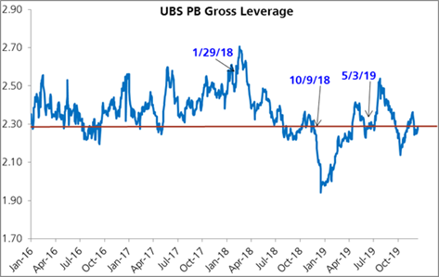  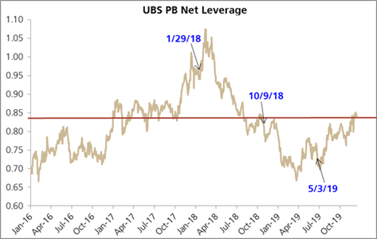

**Figures 16 & 17**

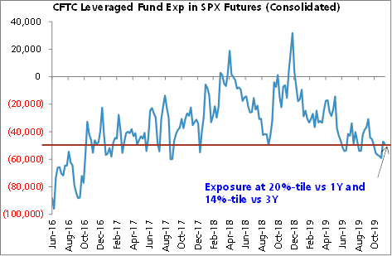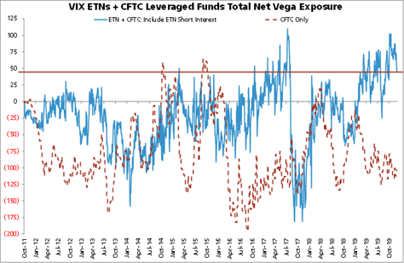

**Figures 18 & 19**

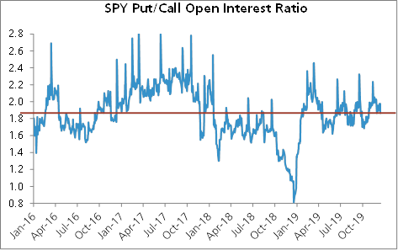  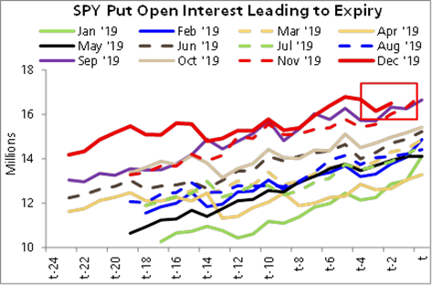

**Figure 20**

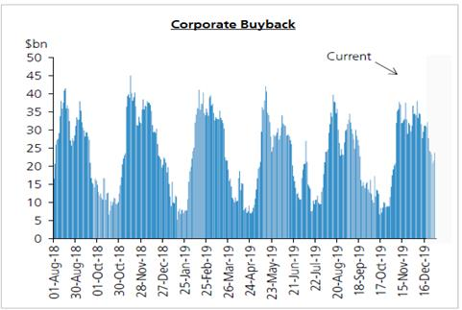

Sources: UBS & Bloomberg

-----Original Message-----

From: Thomas, Dale

Sent: 07 March 2019 20:42

To: FX Team; Barrett, Iomar

Subject: Economic Progress Report: Sensible Shifts in Household Spending - Bank of Canada

https://www.bankofcanada.ca/2019/03/economic-progress-report-sensible-shifts-in-household-spending/

For the Canada nerds out there. This is BoC Dep Gov Lynn Patterson's speech today in which she expanded on the BoC decision. My take is that is even more dovish than the statement. Her conclusion was

"Although we figured the economy was in for a detour at the end of last year, that detour may wind up being longer than we had expected. It now appears the economy will be weaker in the first half of 2019 than we had projected in January. However, we still expect Canadian economic growth to pick up later in the year, supported by ongoing strength in employment and rising wages. We will have more to say in April, when we will have a new economic projection, as well as our annual updated estimates for economic potential and the neutral interest rate.

At yesterday’s decision, Governing Council judged that the outlook continues to warrant a policy interest rate that is below its neutral range. Given the mixed picture that the data present, it will take time to gauge the persistence of below-potential growth and the implications for the inflation outlook. With increased uncertainty about the timing of future rate increases, Governing Council will be watching closely developments in household spending, oil markets and global trade policy"

In the Q&A she apparently said " BANK STAFF IS LOOKING TO SEE IF THE NEUTRAL RATE RANGE NEEDS TO CHANGE". It would be no surprise if in April the BoC lowered its neutral rate to something that is magically close to the current nominal rate. Meaning they can retire the last vestige of hawkishness, the " With increased uncertainty about the timing of future rate increases," line.

**From:** Thomas, Dale   
**Sent:** 01 April 2019 20:19  
**To:** Gloster, Gary; Flow-Prices  
**Subject:** RE: Prices / Poloz

The conclusion was the only mildly Interesting bit

That being said, it is clear that the global economy is performing less well than we believed only a few months ago, and Canada is feeling the effects. In addition, our housing sector is taking longer than previously expected to digest the combined effects of stricter mortgage guidelines and higher interest rates.

That is why we said at our last interest rate announcement in March that the economic outlook continues to warrant a policy interest rate that is below the neutral range, to help the economy work through this downshift in growth and keep inflation close to target. Recent economic data have been generally consistent with our expectation that the period of below-potential growth will prove to be temporary.

Our next interest rate announcement and *Monetary Policy Report* will be released on April 24, and I can promise a fuller analysis at that time. For now, let me thank you for your kind attention, and for your wonderful hospitality here in Iqaluit.

  .He missed out the line about needing rates to eventually rise to neutral

**From:** Gloster, Gary   
**Sent:** 01 April 2019 19:57  
**To:** Flow-Prices  
**Subject:** Prices / Poloz

*DATA SHOW `MIXED PICTURE,' MUST BE CAREFULLY MONITORED: POLOZ

*BANK OF CANADA GOVERNOR POLOZ GIVES SPEECH IN IQALUIT, NUNAVUT

*EXPORT, INVESTMENT GROWTH TO TURN POSITIVE THIS YEAR: POLOZ

*RECENT DATA CONSISTENT WITH TRANSITORY SLOWDOWN VIEW: POLOZ

*POLOZ SEES `MANY AREAS' OF ENCOURAGING ECONOMIC GROWTH

*OIL SECTOR CONTINUES TO ADJUST TO LOWER PRICES, POLOZ SAYS

*HOUSING SECTOR TAKING LONGER TO DIGEST NEW RULES, RATES: POLOZ

*POLOZ SEES `CLEAR SIGNS' CANADA IS ADJUSTING TO CHALLENGES

*POLOZ SAYS PERIOD OF BELOW-POTENTIAL GROWTH WILL BE TRANSITORY

*POLOZ: OUTLOOK CONTINUES TO WARRANT RATES BELOW NEUTRAL RANGE

**From:** Thomas, Dale   
**Sent:** 28 February 2019 17:04  
**To:** meetingsFX  
**Subject:** For FX meeting tomorrow - FX impact of Fed running cpi at 2.3% in order to meet its 2% inflation target

**FX impact of Fed running cpi at 2.3% in order to meet its 2%  inflation target?**

**The long term impact is unclear**

**Conceptual issues**

For a start, conceptually the Fed is doing nothing new, its simply trying to meet its 2% inflation target. There is no suggestion of this changing its inflation target. If the Fed succeeds, then the end result will be a tightening to get inflation from 2.3% to 2%. So there should be no change to the terminal USD forward rate. Working backwards, any move in spot USD will therefore be limited to the kneejerk move lower.  This is not the same as the JPY experience in 2015.  Then there is the reality that  USD moves are driven by changes in economy wide real interest rates  which we cannot observe but can infer. Would a slight (50bp) easing lead to higher or lower economy wide real returns ?

**Fed fund and the USD - history**

First of all the link between Fed policy and the USD is unclear.  If things are soggy enough globally for the Fed cuts rates, we can assume there will be a policy response in the same direction, so this is not the 2005/2007 scenario.  Also, in terms of the recent cycle, the peak in the USD was when Fed funds was 0.625%. Market has been trading the end of the cycle since then.  After an easing, is it going to play the start of the next cycle.  ?

**Fed Funds and the curve**

**Spot the correlation and the causation  ?**

Relative curve shapes have had some influence on EURUSD recently.  If the US curve steepens and the EU curve flattens, does EURUSD go up or down ?

**Running the economy hot and the USD.**

The snakeoil salesmen on the sell side love the expression “running the economy hot”, without  defining what that means.  I would define it as running ex-ante nominal aggregate demand growth ahead of ex-ante nominal supply.  In the world we are in of excess supply (which is why), this means a mix of higher prices and demand leaking overseas. A policy like this should lead to a persistent negative contribution to GDP growth from net exports. Periods of consecutively negative net exports contributions have typically been associated with a higher not a lower USD. And vice versa.  On the capital side, higher nominal demand attracts excess foreign capital.  So running the economy hot means attracting foreign capital which means a stronger USD ?

Bottom line, we cannot complete this sentence with any confidence, “if the fed targets 2.3% CPI for a few years as a way of ensuring its long term target of 2%, the USD will………”

**From:** Tezgul, Mehmet   
**Sent:** 11 March 2019 11:21  
**To:** Adyel, Selim; Bae, Che-Hwon; Biri, Eren; Cisneros, Diego; Cole, Peter; Gloster, Gary; Jelf, Tomas; Kraft, Stuart; Kunur, Omkar; Kurella, Vishnu; Law, Andrew; Linden, Denise; McQuaid, Stuart; Mehta, Mudit; Mittal, Sugandh; Mittal, Vibhor; Mohammad, Junaid; Ng, Shaun; Peck, Matthew; Reddy, Abhishek; Rishi, Tim; Rowe, Aaron; Slade Perry, Charlotte; Sod Hoffs, Gabriel; Thomas, Dale; Turton, Felix; van 't Klooster, Pieter; Wade, Matthew; Yang, Justin  
**Subject:** Btwn the lines from 60min interview - RE: XAUUSD & Change in FED Inflation Targeting

There will be months of debate on this but below excerpt the most critical in what the chair thinks currently: “We haven’t actually said that we want to average 2% inflation.”

Sounds like they *will not actively* pursue average inflation targeting but making sure errors are two way to arrest the lower drift in inflation expectations, which is the main problem – deflation & inflation risks are symmetric.

In theory symmetrically random errors would mean averaging 2% inflation. But errors are anything but normal at the moment – maybe structurally so.

Or is this just semantics and Powell trying to calm down the discussion?

Any thoughts most appreciated.

POWELL: We haven't actually said that we want to average 2% inflation. What we've said is something a little bit different, which is that we look at errors above and below 2% symmetrically. Honestly though, inflation has mostly been below 2%. We haven't had inflation above 2%. And so it has averaged less than 2%. And that's something that is worth thinking about because we want inflation expectations to be anchored at around 2%. And we have to reach 2% sustainably and symmetrically we think for that to be the case in the long run.

PELLEY: Want to make sure I understand. If the inflation rate rises something over 2% for a limited period of time, that doesn't mean the Fed's going to jump on the brakes?

POWELL: I think we wouldn't overreact to inflation modestly above 2% any more than we overreacted to inflation modestly below 2%. I think we'll always be moving inflation back to 2% with our policy. But I think we do that in a symmetric way.

**From:** Tezgul, Mehmet   
**Sent:** 01 March 2019 15:10  
**To:** Adyel, Selim; Bae, Che-Hwon; Biri, Eren; Cisneros, Diego; Cole, Peter; Gloster, Gary; Jelf, Tomas; Kraft, Stuart; Kunur, Omkar; Kurella, Vishnu; Law, Andrew; Linden, Denise; McQuaid, Stuart; Mehta, Mudit; Mittal, Sugandh; Mittal, Vibhor; Mohammad, Junaid; Ng, Shaun; Peck, Matthew; Reddy, Abhishek; Rishi, Tim; Rowe, Aaron; Slade Perry, Charlotte; Sod Hoffs, Gabriel; Tezgul, Mehmet; Thomas, Dale; Turton, Felix; van 't Klooster, Pieter; Wade, Matthew; Yang, Justin  
**Subject:** XAUUSD & Change in FED Inflation Targeting

W/r to XAUUSD the framework is simple so I planned to talk about it. Given we ran out of time, however, please find my thoughts below:

**The potential adjustment to inflation targeting approach discussed at the FED, if implemented, could have significant, bullish implications for XAUUSD. The range of potential outcomes is very wide. As floor and cap one could quantify the following two**(based on the classical frame work of pricing XAUUSD based on USD (JPMQUSD) and real rates (USGGT10Y;) 70-80% R-squared):

In this framework, the stable channel is via real rates, for each 1bsp move in real rate, appx impact on XAUUSD is 1.5-3usd. (I am looking to estimate this more precisely but not much progress yet; might be a polynomial fit.)

Change in USD, though in the regression, is assumed to be 0.

**Scenario 1, floor – min impact**(similar to what Dale was envisioning)

FED overshoots for 1 year (appeases Trump w/ hot economy) but backtracks.

~50bsp ➔ 100usd

**Scenario 2, cap –max impact**

FED makes up for the cumulative inflation missed for ~10y, overshooting its target by a similar amount over the course of next 10 years.

Appx. cumulative miss is  ~800bs ➔ 1600 – gold price doubles – 160usd + drift per year.

**If the policy change comes through I believe the reality will be something in between.**

**Other considerations:**

a) I agree USD impact is unclear as fx is a relative process. Thus, I assume no impact from USD here. Saying that, assuming CBs follow FED conceptually, and change their mandates from effective caps to symmetric averages, I believe impact on XAU in all fiat currencies would be materially positive.

b) Short-term, the reason I remained lukewarm to XAUUSD YTD was expectations of bounce in Chinese activity stabilizing global g and thus, potential for real rates to reprice a degree of hikes. I believe, even if the bounce in g materializes now, given the discussion on inflation targeting framework, it is likely that breakevens absorb such change w/ real rates remaining suppressed. Possibly takes out the downside in XAUUSD.

c) An argument for slow pricing of the policy change is “how will we know” argument. Right now we are at 1.9%. We need to somehow get above towards 2.3-2.5% for market believe the permanency of the change credibly. (What confuses people is, even though the language is not changing, until now the symmetric target was an aspirational goal which you never reach, market might want to see evidence to change this perception. As Andrew said, FED needs to do something itself to get there given the outlook/structural drag. Without that, even if they change policy, we would not have a chance to test the reaction function. Thus, this might be a slow burn.

d) Pricing of the **Scenario 2, cap –max impact**does not need to happen in 10 years as market prices ahead structurally higher inflation expectations. I do not want to sound sensational here but, for fiat currency and hard asset pricing, this debate is much more important than the pause or the balance sheet discussions in my opinion.

e) As mentioned in the meeting, a) Powell seems intend defining the issue a “problem” and effort a “public duty”, b) micro economic framework is robust (Friedman), and c) only part of the inflation conundrum they have control over (vs other theories out there about demographics/savings, technology, China/globalisation.)

f) I think this a 3rd dovish debate FED has opened this year in addition the pause and balance sheet.

**From:** Thomas, Dale   
**Sent:** 23 March 2019 11:40  
**To:** Mittal, Sugandh; Tezgul, Mehmet; Law, Andrew; Desk  
**Subject:** RE: [EXTERNAL] Andrew-- take a look--Charts on Fed Recession Model***

A few thoughts on this

•         Plenty of literature that points to global QE having had a significant impact on term premium on the “global” yield curve, so these curve models probably overstate the recession probability

•         I don’t see the domestic private sector imbalances in the US economy that presaged previous recessions; excess business investment in 1999/2000 and  the consumer debt binge in the mid 2000s. The US is at little danger of a domestic led recession at the moment

•         In the EM world (and DM dependant on EM growth countries), which has been the epicentre of credit reflation since 2008, there are clear recessionary signs as private sector savings rate rise. The private sector in China is in a recessionary period for example

•         The Fed de jure sets rates and influences credit conditions for the USA, de facto it does so for most of the EM world including China.  Given the share of EM activity in the global economy has grown so much in recent years, the Fed’s sphere of influence may well be the largest, in terms of share of global GDP, than it ever has been.

•         Fed policy seems to be just right for the US,  but too tight for the rest of the Dollar area.  The weakness in EMFX in the last few days is a warning sign of this. I am monitoring this carefully.    The flat yield curve may well be signalling a further slowdown in the broader USD economic area.

•         At the same time, risks outside of the USD block are rising. European leading indicators are hinting that the slowdown in external demand  is about to feed through into job losses. The risks to the downside are growing

•         2.5% is not a magic number. It just happens to be where Fed funds are right now. Given global developments, both in the broader USD area and in Europe, Fed funds rate looks too high.

•         Interestingly, the probability of recession reached the same level in 1998. The economic constellation looks very similar to today. Strong domestic demand in the US, weak growth and financial crises elsewhere. The Fed eventually cut rates by 75bps to stabilise things, extending the life of the expansion by 2 to 3 years.  I still think this is the closest historical parallel with today

**From:** Mittal, Sugandh   
**Sent:** 23 March 2019 05:33  
**To:** Tezgul, Mehmet; Law, Andrew; Desk  
**Subject:** RE: [EXTERNAL] Andrew-- take a look--Charts on Fed Recession Model***

Market’s own assessment of US recession is much lower than 53%.

Taking 3 scenarios in which 1) the Fed hikes 25bp, 2) be on hold or 3) cuts back to 0.25% in case of a recession, I only get a **20%** probability of recession.

In other words, if one believes the recession probability is 53%, we should be pricing in 120bp cuts instead of the 45bp in this cycle.

|  |  |  |
| --- | --- | --- |
| Scenarios | Probability | Fed hikes/cuts |
| Scenario 1: Global growth stabilizes; US core CPI >2.2%; Europe/China surprise upside | ***5%*** | +25 |
| Scenario 2: Global growth stabilizes; US core CPI hovers below 2%; no major stimulus from China | ***75%*** | 0 |
| Scenario 3: US recession | ***20%*** | -225 |
|  |  |  |
| Weighted average of cuts priced in (to equate to current market pricing in this cycle) |  | -44 |

**From:** Tezgul, Mehmet   
**Sent:** 23 March 2019 03:05  
**To:** Law, Andrew; Desk  
**Subject:** RE: [EXTERNAL] Andrew-- take a look--Charts on Fed Recession Model***

1) I keep hearing “the decline in term premium this time makes inversion less of a signal.”

I guess near-term forward spreads incorporate less term premium and thus, less susceptible to above counterargument. Would you agree?

2) Beyond 40% probability it looks like there has been one success story of no-recession - 1998-99 episode. Prescient that Powell’s Jackson Whole speech focused on this episode – see below. (Cannot explain why/how Powell pivoted hawkish after this speech in Aug until Dec.) Where will the positive productivity shock going to come from this time?

**Shifting Stars and the "New Economy" of the Late 1990s**  
The second half of the 1990s confronted policymakers with a situation that was in some ways the flipside of that in the Great Inflation. In mid-1996, the unemployment rate was below the natural rate as perceived in real time, and many FOMC participants and others were forecasting growth above the economy's potential. Sentiment was building on the FOMC to raise the federal funds rate to head off the risk of rising inflation.[9](https://www.federalreserve.gov/newsevents/speech/powell20180824a.htm#fn9) But Chairman Greenspan had a hunch that the United States was experiencing the wonders of a "new economy" in which improved productivity growth would allow faster output growth and lower unemployment, without serious inflation risks. Greenspan argued that the FOMC should hold off on rate increases.

Over the next two years, thanks to his considerable fortitude, Greenspan prevailed, and the FOMC raised the federal funds rate only once from mid-1996 through late 1998.[10](https://www.federalreserve.gov/newsevents/speech/powell20180824a.htm#fn10) Starting in 1996, the economy boomed and the unemployment rate fell, but, contrary to conventional wisdom at the time, inflation fell.[11](https://www.federalreserve.gov/newsevents/speech/powell20180824a.htm#fn11)

Once again, shifting stars help explain the performance of inflation, which many had seen as a puzzle. Whereas during the Great Inflation period the real-time natural rate of unemployment had been well below our current-day assessment, in the new-economy period, this relation was reversed (figure 3). The labor market looked to be tight and getting tighter in real time, but in retrospect, we estimate that there was slack in the labor market in 1996 and early 1997, and the labor market only tightened appreciably through 1998 (figure 4). Greenspan was also right that the potential growth rate had shifted up. With hindsight, we recognize today that higher potential growth could accommodate the very strong growth that actually materialized, let alone the moderate growth policymakers were forecasting.[12](https://www.federalreserve.gov/newsevents/speech/powell20180824a.htm#fn12)

The FOMC thus avoided the Great-Inflation-era mistake of overemphasizing imprecise estimates of the stars. Under Chairman Greenspan's leadership, the Committee converged on a risk-management strategy that can be distilled into a simple request: Let's wait one more meeting; if there are clearer signs of inflation, we will commence tightening.[13](https://www.federalreserve.gov/newsevents/speech/powell20180824a.htm#fn13) Meeting after meeting, the Committee held off on rate increases while believing that signs of rising inflation would soon appear. And meeting after meeting, inflation gradually declined.

In retrospect, it may seem odd that it took great fortitude to defend "let's wait one more meeting," given that inflation was low and falling. Conventional wisdom at the time, however, still urged policymakers to respond preemptively to inflation risk--even when that risk was gleaned mainly from hazy, real-time assessments of the stars. With the experience in the new-economy period, policymakers were beginning to appreciate that, with inflation expectations much better anchored than before, there was a smaller risk that an inflation uptick under Greenspan's "wait and see" approach would become a significant problem.

**From:** Law, Andrew   
**Sent:** 22 March 2019 18:40  
**To:** Desk  
**Subject:** Fwd: [EXTERNAL] Andrew-- take a look--Charts on Fed Recession Model***

Begin forwarded message

Here are charts from the recession model:

The model (described [in this Fed post here](https://nam03.safelinks.protection.outlook.com/?url=https%3A%2F%2Fwww.federalreserve.gov%2Feconres%2Fnotes%2Ffeds-notes%2Fdont-fear-the-yield-curve-20180628.htm&data=02%7C01%7CALaw%40caxton.com%7Ca6fc5491fa3841f6056e08d6aef00ced%7C70c99524736c49f4b73e75d7fa126cf9%7C0%7C0%7C636888743373080108&sdata=WE6RkYjtRvgdyA9qurJv7Y7s5uTfRP%2FMKKwcK%2BFT7b8%3D&reserved=0)) uses a near-term forward spread as a proxy for market expectations of Fed policy to estimate recession probabilities.

The near-term forward spread – estimated here by interpolating between the 1y3m and 2y3m forward UST rates and taking the spread versus spot 3m T-bills – currently stands at -30bp, a low since January 2008.

Based on the Fed staff’s recession probability model [referenced in this morning’s WSJ article](https://nam03.safelinks.protection.outlook.com/?url=https%3A%2F%2Fwww.wsj.com%2Farticles%2Fanalysis-fed-chairman-jerome-powell-shows-his-flexible-side-11553247000%3Fmod%3Dhp_lead_pos6&data=02%7C01%7CALaw%40caxton.com%7Ca6fc5491fa3841f6056e08d6aef00ced%7C70c99524736c49f4b73e75d7fa126cf9%7C0%7C0%7C636888743373090113&sdata=hbndDMQlWdD2%2FPHfntEJ0IXa2pN5wHcukOyIhhoQXaA%3D&reserved=0), **the model gives a recession probability of 53%.**

Robert Rosener, Vice President     
**Morgan Stanley | Research**1585 Broadway, 38th Floor | New York, NY  10036     
Phone: +1 212 296-5614     
[Robert.Rosener@morganstanley.com](mailto:Robert.Rosener@morganstanley.com)     
  
Morgan Stanley’s US Economics team has been awarded the 2018 Blue Chip Lawrence R. Klein Award for the most accurate forecasts over the past 4 years. Read the press release [here.](https://nam03.safelinks.protection.outlook.com/?url=https%3A%2F%2Fwww.prnewswire.com%2Fnews-releases%2Feconomic-growth-expected-to-slow-significantly-in-2019-chief-us-economist-ellen-zentner-of-morgan-stanley-wins-lawrence-r-klein-award-for-forecasting-accuracy-300715543.html&data=02%7C01%7CALaw%40caxton.com%7Ca6fc5491fa3841f6056e08d6aef00ced%7C70c99524736c49f4b73e75d7fa126cf9%7C0%7C0%7C636888743373100123&sdata=8trUSQa4kNPp%2BNGk0yFa4yyjmr%2BhKdl3SOlfElm2eMY%3D&reserved=0)  
     
     
Be carbon conscious. Please consider our environment before printing this email.    

This is sales and trading commentary prepared for institutional investors; it is NOT a research report; tax, legal, financial, or accounting advice; or an official confirm. The views of the author may differ from others at MS (including MS Research). MS may engage in conflicting activities -- including principal trading before or after sending these views -- market making, lending, and the provision of investment banking or other services related to instruments/issuers mentioned. No investment decision should be made in reliance on this material, which is condensed and incomplete; does not include all risk factors or other matters that may be material; does not take into account your investment objectives, financial conditions, or needs; and is not a personal recommendation or investment advice or a basis to consider MS to be a fiduciary or municipal or other type of advisor. It constitutes an invitation to consider entering into derivatives transactions under CFTC Rules 1.71 and 23.605 (where applicable) but is not a binding offer to buy or sell any financial instrument or enter into any transaction. It is based upon sources believed to be reliable (but no representation of accuracy or completeness is made) and is likely to change without notice. Any price levels are indicative only and not intended for use by third parties. Subject to additional terms at <http://www.morganstanley.com/disclaimers/productspecific.html>.  By communicating with MS, you acknowledge understanding of, and consent to, the foregoing and to the voice recording of telephone conversations with personnel of Morgan Stanley.

**From:** Thomas, Dale   
**Sent:** 09 April 2019 16:16  
**To:** Jelf, Tomas; Law, Andrew; Desk  
**Subject:** RE: job openings

Quit rates are high, but may be peaking while discharge rates are at cycle lows, as is unsurprisingly the jobless claims rate    Firms are not firing and employees are not afraid to quit to look for other jobs.  At the same time,  weakness in the internals of the job report and the weak hiring components of the NFIB survey point to a fall off in labour demand.

**From:** Jelf, Tomas   
**Sent:** 09 April 2019 15:29  
**To:** Law, Andrew; Desk  
**Subject:** RE: job openings

Third largest drop on record. What’s unusual is that it doesn’t follow a large increase in the prior month. See chart below.

That said, even if this is the peak a recession may be far off. E.g. in the prior cycle job openings peaked 20 months before the recession.

That peak coincided with the first top in the pre-2008 double top in yields while equities continued to move higher. See chart below.

Only one event so the observation has to be treated as such.

**From:** Law, Andrew   
**Sent:** 09 April 2019 15:01  
**To:** Desk  
**Subject:** job openings

**From:** Thomas, Dale   
**Sent:** 15 April 2019 15:00  
**To:** FX Team  
**Subject:** MXN longs on IMM have got to elevated levels

Interesting that MXN net spec longs on IMM are as long as they have ever been, with considerable length added over the last month.  IMM data needs to be taken with a pinch of salt and with MXN having the best carry to vol ratio of any liquid EM currency it is no surprise that the IMM position is large, nonetheless it suggests there has been a large build-up of EMFX longs in Q1 to levels that historically have been unsustainable.

**From:** Thomas, Dale   
**Sent:** 16 April 2019 11:02  
**To:** Desk  
**Subject:** RE:

Charts by Macquarie also highlight the fiscal stimulus as well as where the main changes in TDF were.  Chinese have really thrown the kitchen sink at this, despite subdued end-user demand for cresit

|  |  |  |
| --- | --- | --- |
|  |  |  |
| |  |  |  | | --- | --- | --- | |  |  |  | | Source: CEIC, Macquarie Macro Strategy, April 2019 |  |  | |  |  |
| Source: CEIC, Macquarie Macro Strategy, April 2019 |  | Source: CEIC, Wind, Macquarie Macro Strategy, April 2019 |

**From:** Tezgul, Mehmet   
**Sent:** 16 April 2019 08:09  
**To:** Law, Andrew; Desk  
**Subject:** RE:

*CHINA 1Q FISCAL SPENDING RISES 15% Y/Y, MOF SAYS

Neither the Local Gov/other off-balance sheet items nor the VAT/social sec payment/fee cuts would be included here.

**From:** Law, Andrew   
**Sent:** 16 April 2019 07:39  
**To:** Desk  
**Subject:**

CNY rates back-up now approaching similar post-stimulus one in q2 2016

**From:** Thomas, Dale   
**Sent:** 24 April 2019 11:41  
**To:** FX Team  
**Subject:** USD upside vs EM - Early contribution to FX meeting on Friday

**Early contribution as I am away for the rest of the week**

**USD upside vs EM, commodity currencies**

Rationale

•         On the economic front, the bottom line is that better China growth trajectory is priced in, with a high bar for near-term positive surprises; growth in the high yielding EM countries is awful and not getting any better.  Taiwan and Korea are not bouncing.   Final demand growth in US and EU seems to have transitioned from well above potential to around potential.  The key global inflation reading, China PPI points to further disinflation.   Taken all together, is seems that global growth has stabilized at lower levels with no sign of an aggressive bounce-back.  This will eventually put further downward pressure on global inflation, which is already too low  So-so growth in the EU and US is just not good enough to create inflation, while the rest of the world is exporting disinflation.

•         As far as markets go, there has been large buying on EM markets despite an unsupportive growth environment.  US dollar cash continues to be a high performing asset in return to risk terms.  Negative USD sentiment is widespread.  European and EM Asia stocks have already priced in a strong cyclical rebound.

•         Clear opportunity for the USD to outperform vs EM and US assets in general to outperform EM assets

 There are also implications for other markets.  A stronger USD would (justifiably ) be taken as a sign US policy is too tight,   With a weakish global backdrop, the US and EU authorities need to target final demand growth well above trend to hit their inflation targets.  For now, they can hope that the rebound in financial conditions may work some magic, but if it does not the authorities will have to boost stimulus. Rate cuts are likely to come into the front end of all curves

**ECONOMY**

**Chinese data better to travel than arrive**

Chinese data was always likely to be strong, given the very late LNY and an aggressive push to create short term credit in the finance system.  But that is more than fully priced now.  There is  a very high bar for Chinese April and May data to beat expectations.  Longer term, the boost in TSF is unsustainable without an sharp increase in housing credit, which would challenge the structural deleveraging dynamic.

**PMI Seasonal pattern is for softness until Q3**

In China, as everywhere growth in home loans is needed to drive credit growth on a sustainable basis

Substantial credit explosion will lead to large C/A deficit

Inflation leading indicator heading lower

**HY EM very weak**

As for the rest of the world. It is clear that the major EM economies are all in bad place with weak growth on both the supply side and the demand side.  All these economies are still in a deleveraging mode after the credit binge post 2006.  Current accounts are heading into surplus as net national savings rates rise.   These countries will import growth on a marginal basis from the rest of the world, a structural recipe for weak currencies.

Chart of IP growth

No recovery in NE ASIA

Mediocre final demand growth in EU and US.  More mediocre in EU , less mediocre in US, but mediocre nonetheless

Final demand growth in the EU and US seems to have stepped  down to a 2% level in Q4, and there of just below in Q1.  There seems little reason to expect a recovery in Europe in q3.  In the US, the broad sweep of data is a bit more positive, and spare capacity is lower.   The USA remains the best looking pig in the st. A decent working assumption is that final demand will not  move much from here,.   Inflation will continue to head lower in this environment

**Markets -**

There has been significant accumulation of EM and EM related assets in recent months.

Imm MXN SPEC LONGS VS MXNUSD

Risk reversals back to last summer level

Europe automakers vis zew current conditions

Technical

So far USD just going sideways

**From:** Thomas, Dale   
**Sent:** 13 May 2019 10:39  
**To:** FX Team  
**Subject:** Housing bubble in Australia continues to delfate

The Australian housing bubble continues to deflate.  A very poor reading on new home loans today.  Prices are likely to follow.  Declining home loan advances, declining prices will both weigh heavily on consumer spending.  There is every reason to expect a further deceleration in GDconsumer spending from the current level around  1.5% per annum.  RBA forecasts still too optimistic.  The obvious policy response to this ongoing decline in provate demand is an aggresive boost to fiscal spending but there is little sign of this. In its absence,  monetary policy/exchange rate will have to take up the slack

**From:** Thomas, Dale   
**Sent:** 15 May 2019 11:36  
**To:** meetingsFX  
**Subject:** USD outlook in US/China trade war environment- cor FX meeting

**Summary**

•         **Limited first round impact  USDCNY higher**

•         **Mildly USD positive 2nd round impact unless Europe is dragged in to trade wars, in which case it is very clear USD positive**

•         **USD largely range-bound until the global cycle turns up**

•         **USD negative and USD positive scenarios exist for the range break; trade wars make the positive one more likely**

•         **No sign that the muti-year USD bull market is over yet**

**Academic theory**

**First round impact**

IMF paper “Macro economic consequences of tariffs” is the best place to start.  <https://www.google.com/search?q=imf+impact+of+tarriffs&sourceid=ie7&rls=com.microsoft:en-GB:IE-Address&ie=&oe>=

First round impact is clear.  Higher tariffs lead to a near offsetting move in real exchange rates.  USDCNH should all other things being able move to reflect the change in tariffs.  This should lead to a small one off increase in the USD vs broader currencies.

**Second round impact of US/China tariff**

US/China tariffs will have a dampening impact on global activity in all regions. The relative impact of this is unclear. Europe seems more vulnerable to this than the US, given the higher export and manufacturing exposure but it does not seem enough to change relative supply and demand dynamics yet.

**Second round impact of US extending trade war to Europe**

This will be a clear negative for the European economy given the relative trade balance and Europe’s higher sensitivity to trade. EURUSD would have to adjust accordingly lower from both first round and second round effects

**Evidence of impact**

**Recent currency moves**

**Currencies indexed to 100 12 months ago**

Currency markets have become becalmed with very low levels of volatility and tight ranges. Evidence that the expected limited impact from tariffs has in fact been seen.  Seems unlikely to see much change in EURUSD until there is a change in global and relative economic momentum.  AUDUSD can continue its steady decline based on domestic factors.  Two possible exit regimes for  the USD, depending on which country leads the global economy out of the current inventory slowdown.  The key is to focus on which is most likely and how the trade war impacts the relative ex-ante probabilities of each option. For simplicity I have just focused on EURUSD.

**Future medium term USD trend**

**USD negative**

The three post GFC upturns have been led by EM and Europe, leading to upward pressure on EURUSD,  This is still  the consensus template for the next upturn. This requires one more bout of re-leveraging by EM countries in aggregate.  Given the weakness in Latam , Turkey and Africa, this really means China.  Any such episode will I think be a pale shadow of previous ones, but could still lead to a small USD sell-off.  The probability is reduced by ongoing trade war

**USD positive**

An alternative is that the US economy leads the global cycle, as it did in the run-up to the end of the last USD bull market in the late 1990s.  A late cycle productivity boom , much higher domestic return on capital sucked money into the US and growth out of the US.  USD correlation with global growth flipped into being positive.   I expect this to happen in the next few years, whether it is this mini-cycle or the next one is not certain. But, it is coming because the US private sector has the potential to be the biggest positive influence on global growth.   Trade tariff concerns make this more likely

**USD long term trend. Unfinished business**

I think there is another leg in the muti-year USD cycle.   It is the highest yielder, a commodity currency, with the best growth prospects.  This suggests we should be on high alert for a flip in the correlation between the USD and the global cycle, something that is made more likely by the prospect of trade wars

USD peaks tend to follow periods when US economy aggressively exports growth via the net trade channel.  We are not there yet